**TASK ONE**

**CHURN ANALYSIS**

**Definition:** Churn analysis is the evaluation of a company's customer loss rate in order to reduce it. Also referred to as customer attrition rate, churn can be minimized by assessing your product and how people use it. Related. Metrics & performance.

**CHURN MODEL**

* Get customers
* Don’t lose customers

Who are those that are churned? Customers who haven’t placed an order in the last X days.

**CHURN RATE**

Churn rate (also called attrition rate) measures the number of individuals or items moving out of a collective group over a specific period. It applies in many contexts, but the mainstream understanding of churn rate is related to the business case of customers that stop buying from you.

Churn rate is a critical metric of customer satisfaction. Low churn rates mean happy customers; high churn rates mean customers are leaving you. [According to **Forbes**](https://www.forbes.com/sites/jiawertz/2018/09/12/dont-spend-5-times-more-attracting-new-customers-nurture-the-existing-ones/?sh=badf6205a8e0), it takes a lot more money (up to five times more) to get new customers than to keep the ones you already have. Churn tells you how many existing customers are leaving your business, so lowering churn has a big positive impact on your revenue streams. Churn is a good indicator of growth potential. Churn rates track lost customers, and growth rates track new customers—comparing and analyzing both of these metrics tells you exactly how much your business is growing over time. If growth is higher than churn, you can say your business is growing. If churn is higher than growth, your business is getting smaller.

**TELCO SYSTEMS**

**Telco** is the term for a telecommunication operator, that is a company that provides telecommunications services such as fixed-line, mobile and data services for end-customers.

**Telco Systems** is a global leader in telecommunications, with over 40 years of experience in the design and development of high-performance network communications solutions. With its advanced software and hardware solutions, Telco Systems provides a revolutionary approach to the network edge for service providers, allowing them to offer the highest levels of service innovation to customers. Operating on the cutting edge of technology, Telco Systems provides solutions for current carrier Ethernet networks, as well as the latest NFV network architectures.

**TELCO CHURN ANALYSIS**

Telco customer churn dataset was collected from kaggle which focuses on customer’s retention and its attributes are:

1. Customers data: Customers who left within one month.
2. Services that each customer has signed up for – phone, multiple lines, internet, online security, online backup, device protection, tech support, and streaming TV and movies.
3. Customer account information – how long they’ve been a customer, contract, payment method, paperless billing, monthly charges, and total charges.
4. Demographic info about customers – gender, age range, and if they have partners and dependents.

**METHODOLOGY**

The statistical software used for this task are Python (Jupiter notebook), Orange and Power bi. The data was trained, Tested and splited using sklearn then visualised using power bi desktop.

**TELCO CHURN DASHBORD**

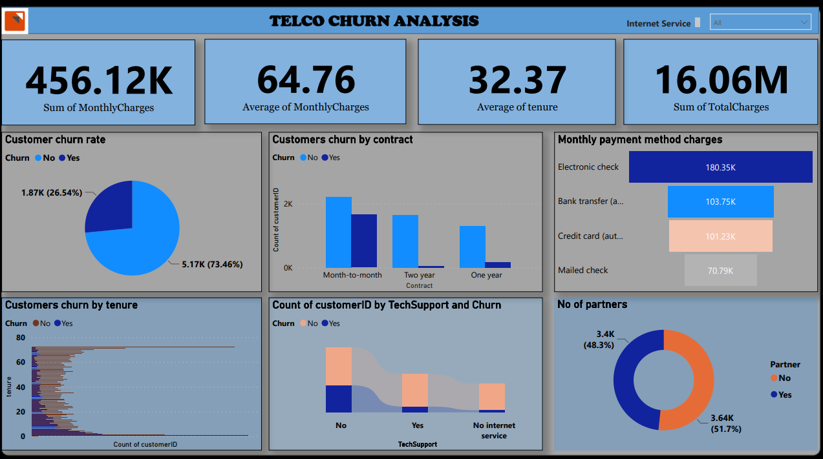

Telco data was collected from Kaggle, data was train, tested and visualized. The data above shows that the sum of **monthly charges** is 456.12k, **average monthly charges** is 64.76, **average number of tenure** a customer comes is 32.37 and **sum of total charges** is 16.06M. The dashboard above also analyses the **churn rate** of the customers that 26.54% churned while 73.46% did not churn. **Customers churn by contract** shows that only month to month customers are more likely to churn. **Monthly payment method charges** show that electronic check and bank transfer are the top 2 common monthly payment method. **Customer churn by tenure** shows that customers will unlikely churn if tenure is > 1. **Customers with tech support** will churn if frequently been supported.